Name of App | Cost | Uses | Teacher/Student | Notes
Archery Free | Free | Bow and arrow shooting challenge for when students are waiting their turn to shoot during an archery unit. | Student
Canvas | Free | For managing classes, flipping the classroom, communicating with students, posting assignments and videos. | Teacher and Student
Coaches Eye | $4.99 | For recording students performing and skill and watching back in slow motion. You can also compare one video to another side by side. | Teacher and Student
Easy Tag | $3.00 | Teacher can create custom panels to analyze a skill. Students get immediate feedback on performance. Easy Tag Bingo (demonstrated in session) | Teacher and Students
Eat-and-Move- O-Matic | Free | Teaches kids to make better decisions about moving and eating. Shows students how much they would need to move in order to burn the calories in what they eat. | Students
Edmodo | Free | For managing classes, flipping the classroom, communicating with students, posting assignments and videos. | Teacher and Students
Fit Brains for Kids  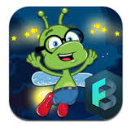 | Free | Activities to get the brain active. | Students under the age of 9
Fitnessgram | Free | Allows you to input scores instantly from anywhere and automatically syncs with Fitnessgram 10.0. | Teacher
My Fitness Pal  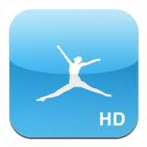 | Free | Staff wellness. With this app you can track your exercise, diet and it will tell you how many calories you can have over a given time to lose a selected number of pounds. | Teacher
What’s My Heart Rate | Free | Reads heart rate. | Students
NFL Play 60  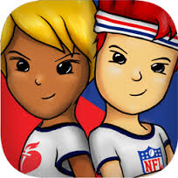 | Free | Similar to Temple run only the students power the character by running and jumping in place while holding their device close to their body. Includes resources and suggestions of how to get out and play. | Students
Personal Best | $.99 | For personal wellness. A quick and simple tool to see how much you have improved on each exercise. | Teacher
QR Reader  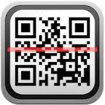 | Free | Scanner to read QR codes. Codes can be created on QRstuff.com and printed for students to scan. Great for warm up or leveled practice tasks. | Students
Seconds Pro  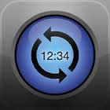 | $4.99 | Timing stations and music in the classroom. Allows you to save your favorites.  Note – there is a free version but you cant save. | Teacher
Slow – Motion Video Player  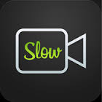 | Free | Slow motion video analysis. | Teacher and Students
Ubersense Coach | Free | Slow motion video analysis. | Teacher and Students
Virtual Heart  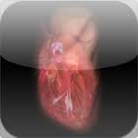 | Free | Show the interior, electrical system, and valves of the heart at different beats per minute. | Students

