“Eyes-Up, Hands-Up”
3-5

“Eyes Up, Hands-Up” From greatactivitiesonline.com/eyes/up/hands/up
- This is a great action- packed game that involves plenty of throwing and catching skills as well as teamwork!
- The object of this game is to get as many balls in the barrel as you can before the time limit is up.

- Divide the students into 2 teams.
- On the teacher’s signal, the students start throwing the balls to get them to land in other team’s barrels during a 2-minute round.
- Once the balls are inside a barrel, they may NOT be taken out.
- Students must stay on their own side of the playing area when throwing a ball. However, they may cross the Center Line if they decide it is safe to retrieve a loose ball.
- Each team may assign up to several “defenders” who will stand 3-4 feet in front of the team’s barrel. Have a designated “restraining line” if needed so the defenders don’t get too close to the barrel.
- Students crossing the Center Line may be tagged by players on the other team.
- When a student is tagged, he must leave the ball on the ground and return to his side of the playing area.
Start of Play During Play (with holding zones)
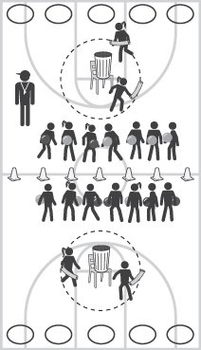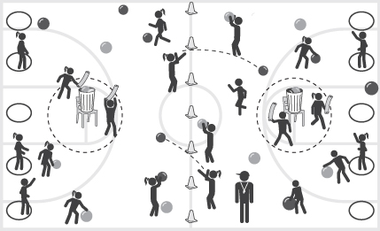
- Optional: If your older students are tagged, they must go to the designated “Holding Zone” area as seen in the diagram (hula hoops). If one of the tagged players is able to catch a ball thrown by a teammate, all of the students are free and get a “free walk” back to their side.

