Sabrina Bundy Rock Hill School District 3 Karen Roof
sbundy@rhmail.org rockhillelementarype.weebly.com kroof@rhmail.org

Hurricane

Objective: Students will connect movements with the characteristics of a hurricane

Characteristics of a hurricane to be focused on:
Counter-clockwise wind rain
flooding tornados eye of the storm

Organization: Students are in a large circle around the perimeter of the room

Parts of a hurricane and movements:

Wind: walk/jog in a counter-clockwise direction (space will determine walking/jogging)
Rain: tiny up/down jumps in place on tippy toes
Flooding: lie on the floor like a pencil and rock back & forth on your back
Tornados: Spin to the middle of the play area (or spin in place)
Eye of the Storm: Freeze like a statue, the center of the storm is calm and is passing by with more
wind, etc. on the way.

How to play:

Students are in a large circle around the perimeter of the room. The teacher introduces by asking “What is a hurricane?” As each characteristic is discussed the students perform the movements that represent each part of the hurricane by moving around the play area in a controlled manner. Allow students to practice each part of the hurricane then begin to mix the parts to allow them to practice all parts.

Extended learning:

Safety Considerations During a Hurricane:
Stay away from low-lying and flood prone areas.
- Always stay indoors during a hurricane, because strong winds will blow things around.
- Leave mobile homes and to go to a shelter.
- If your home isn’t on higher ground, go to a shelter.
If emergency managers say to evacuate, then do so immediately.

AFTER A HURRICANE:
- Stay indoors until it is safe to come out.
- Check for injured or trapped people, without putting yourself in danger.
- Watch out for flooding which can happen after a hurricane.
- Do not attempt to drive in flooding water.
- Stay away from standing water. It may be electrically charged from underground or downed power lines.
- Don’t drink tap water until officials say it is safe to do so

Extended lesson (depends on your standards):
- Conditions needed for a hurricane to develop (warm temps over the ocean, moisture)
- Characteristics: wind, rain, flooding, tornados, eye of the storm
- Safety info: (http://www.weatherwizkids.com/weather-safety-hurricane.htm)
- Hurricane season (6/1-11/30)
- Higher level students: names of hurricanes, categories, warning/watch
- I like to do this by questioning rather than lecturing to learn students’ prior knowledge

(South Carolina Science Standards in 2nd & 4th grade)

Race-N-Chase

Station: 4

Equipment needed: 4 cones, 2 batons, start lines

Objective of the game:
- Catch up with and pass the runner on the other team
- Make good hand-offs to team mates as if on a track team
- Power walk, skip, run (in this order please)

Organization: (Homeroom teacher should help with this)
- Cones should be set up to make the area look like a track
2. Divide the class into two teams (I do this by asking students to choose a partner to challenge.)
3. Teams line up on the opposite sides of the “track” at the designated spot
4. One team faces one direction while the other team faces the opposite direction

How to play:
- The line leader from each group has a baton to carry while going around the track
- On the signal “GO” the lead student of each group begins to move around the perimeter of the track. Both students are moving in the same direction.
- Each student moves around the perimeter of the cones as quickly as possible. When the runner returns to his/her group hand the baton to the next person in line. This person begins to move around the track immediately to complete his/her time. A line will mark the handoff area.
- After the hand-off go to the back of the line. Caution the students: be careful not to get bumped while going to the back of the line to avoid a penalty of 1 point).
- Begin the game with a Power Walk, then Skip, finally Run

Scoring:
- Start a new game if the score is 1-0. (If a point is scored the game is over and a new game
should be started)
- Points are scored if:
- A runner is passed (award the team that passes)
- Obstruction: someone gets in the way of the runner and he/she has to slow down (award the other team)
- A runner cuts the corner (award the other team)
- A runner jumps/steps over a cone (award the other team)
- A runner knocks the cone down (award the other team)
- Running when they should be doing another skill (award the other team)

GOTCHA

Divide the class into 2 teams. Team 1 is trying to get the tennis ball from the cone on team 2’s side and bring it back to their side and place it on their cone. The team that gets all 8 tennis balls on their cones wins. If tagged on the other team’s side then they will go to the hoop which is the brig. They are only in the brig until a teammate gets tagged and takes their place. When they get free from the brig they stay out of bounds until they get back to their side. Going out of bounds on the other team’s side is safe but they must come back to their side before re-entering the game. There should never be more than 1 person in their brig at a time.

Δ Δ

° °
Δ Δ

Δ Δ

° °
Δ Δ

Δ Δ

° °
Δ Δ

☺ hoop ☺hoop

RESPECT

Card Game (RESPECT): There will be 7 lines, one behind each fruit. Students will jog to the other end of the gym and turn over a card (which are all scattered on the floor.) If it is their fruit they will bring it back, if not, they will turn it back over and jog back to the next person. Once they have collected 7 cards, they will sit down. When all groups are finished, they will go to an open space in the gym and work as a team to decipher the word RESPECT. Once each group has completed the task they can stand up and do a victory dance or exercise. I will call them all over to one group and go over the expectations for the school year in PE based on the sentences on the cards.

High 10 Tag
Everybody’s IT
Very simple Instant Activity to use as a warm-up or when you have a few minutes left in class. Everyone is it, you can be on base by putting both hands on your knees. If you get tagged you will raise both hands. 2 DIFFERENT people must tag your hands to set you free. You are not allowed to move while on base, come off of base just to tag (must take 1-2 steps before tagging someone)

Boom City
Divide the class into 2 teams and choose 3 students from each team to be the catchers. The catchers stand on mats at the opposite end of the gym form teammates. Students use foam/yarn/soft balls to throw to catchers and when they catch a ball they slam the ball down and yell “BOOM CITY” then run to middle of gym and pick up a beanbag for their bucket-count the bean bags at end of each game (2 minutes) then change out the catchers.

Scooter Basketball
Half the class will be on one set of scooters and the other half will be on the other set of scooters. Students must be sitting on scooters (they are not allowed to be on their knees and NEVER stand on the scooters.) This is basically a basketball game and the students will throw the ball towards the barrel. The main rule is that they cannot roll on their scooter if they have the ball (that is like traveling in basketball-it also stops the ball hog that would keep the ball and try to score every time). Their choices are to pass to a teammate or shoot at the goal. Students must be on their scooters to get the ball and they cannot foul the other team. To start the game, just throw the ball off of the wall and there are no out of bounds. If there is ever a jump ball, again throw the ball off of the wall. After a team scores, the other team gets the ball.
One rule is the semi-circle around the barrel-they cannot shoot or block from inside the tape.

Remind them to keep their fingers off the scooter and off the floor!

Also, I play this in teams of 5-6 and make it a round robin.

Save the Fortress:
18 Plastic bottles with sand in the bottom (9 on each side)
10 small gatorskin balls (6")

2 teams play at one time, depending on the size of the class you can divide in 2 or 3 teams. Set the bottles up like the diagram below. The object is to roll the ball to the other side and knock down the other team’s bottles. The first team to do so is the winner. You can guard the bottles but you can’t stand behind the guard line to block. The guard line is either the green or brown line on the floor depending on the side of the room. You must roll the ball and not throw it. I give one warning if they throw the ball overhand and the second time they are out of that game. Remind them not to kick the ball but they can use their feet to stop the ball. Put orange spots down to designate the center line and students cannot reach over the line to get a ball. If it is on the line then either team can get it
Once all of the bottles are down, the students switch sides-high five and say good game-set up the bottles and wait for the word go!

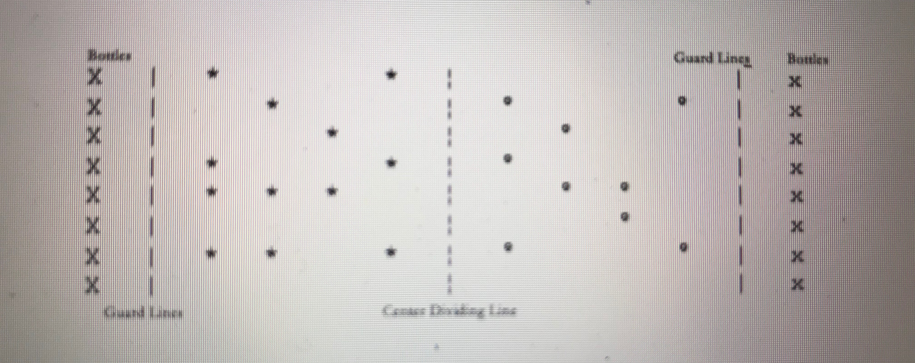

Hula Hut Throwdown Meets Save the Fortress

Divide the class into 2 teams. The object is to knock all of the bottles down and have the most huts built. On the word GO, the students can build their huts anywhere in the playing area. The balls are used to knock down the bottles and knock down any existing huts. When a hut is knocked down, the team works to rebuild it. Then they will try to protect it so the other team doesn’t throw a ball and knock it down. The winner is the team that has the most huts up and most bottles up when the horn sounds to rotate stations.

Star Wars
(Arghh)

Students will be divided into 3 groups- The purpose of the game is to have the least amount of equipment in your playing area.
Divide the playing area into thirds-each group goes to a playing area. Rotate positions after 2-3 minutes of play.

Group 1 = Jedis (Pirates)– they will throw using a mature throwing pattern over the wall (standing mats or sheet over volleyball net) to the stormtroopers.
Group 2 = Droids (Swashbucklers) - they will be on scooters and will retrieve the equipment and toss to either side
Group 3 = Stormtroopers (Scalawags) - catch equipment and throw it back over the wall to the Jedis (Pirates)

Jedis Droids Stormtroopers

